Anvay KYC Requirements Pack
Nov 4, 2026 · @Abhinav

Part A: Business Requirements Document (BRD)

1. Document control
Field | Detail
Project | Anvay KYC Onboarding Remediation
Document | Business Requirements Document (BRD), version 0.1
Status | Draft for review
Author | Abhinav Kotar
Client | Anvay Money, a fictional neobank. All figures come from a simulated funnel.
Related | FRD (Part B), traceability matrix (Part C), clickable prototype

2. Background and business problem
Two in three new Anvay Money customers abandon account opening before KYC is complete, and the largest single loss is the Aadhaar upload step.
In a simulated funnel of 10,000 sign-ups, 67% dropped off before finishing onboarding, so only 3,300 (33%) completed KYC. Python cohort analysis isolated Aadhaar upload as the critical failure point, with 38.5% lost at that step. The analysis separated two kinds of exit:
- Trust-driven: the user hesitates because the screen asks for a sensitive document and never says why, what is stored, or who sees it.
- Technical-driven: the user tries, but the photo is rejected after upload with a generic "Image not clear" error, so each retry repeats the whole step.
Current-state process. The user enters a mobile number, enters an OTP, uploads the front and back of the Aadhaar card, types the 12-digit number, and waits for a quality check. A failed check returns a generic error and sends the user back to the upload screen.
These figures are simulated. Every target in this document must be re-baselined on live funnel data before build.

3. Objectives and success metrics
The project succeeds if more new customers finish KYC without weakening compliance, and the main lever is cutting the 38.5% loss at Aadhaar upload.
ID | Objective | Measure | Baseline (simulated) | Target
OBJ-1 | Raise KYC completion | Share of sign-ups that complete KYC | 33% | Set after a live baseline and pilot
OBJ-2 | Cut loss at the identity step | Share of users lost at the Aadhaar step | 38.5% | Under 20% (proposed, to be tested)
OBJ-3 | Know why users leave | Share of exits tagged trust-driven or technical-driven | Not tracked | 100% of exits tagged
Guardrails. The new flow must not raise the details-mismatch rate on the review screen, and consent must be recorded for 100% of identity-data fetches. A gain in completion that breaks either one is not a success.

4. Scope
In scope | Out of scope
Mobile number and OTP steps | KYC steps after the identity step
Identity step: DigiLocker fetch, photo fallback, review and confirm | Account funding and first transaction
Consent capture and masked display of the Aadhaar number | DigiLocker's own screens and approval flow
Funnel event tracking, with exits tagged by cause | Fraud scoring and risk models

5. Stakeholders
Stakeholders are listed by role because Anvay Money is a fictional client.
Stakeholder | Interest | What they need from this project
Product owner | Completion rate and cost per verified customer | A prioritised scope and a clear success measure
Compliance and risk | Meeting RBI KYC rules, audit readiness | Numbered regulatory requirements and a consent record they can audit
Engineering | Buildable, unambiguous requirements | Acceptance criteria and a defined fallback path
Data and analytics | Reliable funnel measurement | Event definitions and exit tagging
Customer support | Fewer "my KYC failed" tickets | Clear error reasons and a way to retry
New customer | A short, trustworthy sign-up | Knowing why data is needed and what happens to it
DigiLocker (external) | Correct use of its fetch interface | A stable integration with a defined failure path

6. Business requirements
Seven business requirements cover the trust and technical causes of drop-off, and each ties back to an objective. Priority uses MoSCoW (Must, Should, Could).
ID | Requirement | Priority | Objective | Cause addressed
BR-01 | A customer can verify their identity without photographing a document. | Must | OBJ-2 | Technical
BR-02 | Before giving consent, the customer is told what data is collected, why, and what is not collected. | Must | OBJ-2 | Trust
BR-03 | A customer without DigiLocker has an alternate route, and a failure there gives a reason and a way to recover. | Must | OBJ-1 | Technical
BR-04 | If the SMS code is late, the customer can get it by another channel. | Should | OBJ-1 | Technical
BR-05 | From the first screen, the customer can see the steps ahead and that an ID step is coming. | Should | OBJ-2 | Trust
BR-06 | Every exit from the onboarding funnel is tagged with a cause category. | Must | OBJ-3 | Both
BR-07 | The customer confirms the fetched details before verification completes. | Must | Guardrail | Both

7. Regulatory requirements
Four regulatory requirements apply to the identity step. They are my working interpretation of the RBI KYC rules and must be confirmed by Anvay's compliance team before build, including exact wording and any rule references.
ID | Requirement | Status
REG-01 | Explicit customer consent is obtained and recorded, with a timestamp, before any identity data is fetched. | Confirm with compliance
REG-02 | The full Aadhaar number is never displayed. It appears only in masked form. | Confirm with compliance
REG-03 | Only the identity data needed for KYC is collected and kept. The retention period is set by compliance. | Confirm with compliance
REG-04 | Consent and verification events are logged and can be retrieved by customer for audit. | Confirm with compliance

8. Assumptions, constraints and dependencies
The plan rests on two assumptions that live data could overturn: that the simulated funnel resembles real behaviour, and that enough customers have a DigiLocker account.
Assumptions
- The simulated 10,000-user funnel is a fair stand-in for Anvay's real sign-up behaviour.
- A meaningful share of target customers already have a DigiLocker account. This share is not yet known.
- Slow OTP delivery contributes to drop-off. This comes from the prototype design and was not measured in the simulated analysis.
Constraints
- The flow must follow the RBI KYC rules, as confirmed by compliance (Section 7).
- DigiLocker's own screens and approval steps are outside Anvay's control.
Dependencies
- Access to DigiLocker's fetch interface for Anvay.
- Compliance sign-off on REG-01 to REG-04.
- Analytics events for funnel steps, so exits can be tagged (BR-06).

9. Risks
Risk | Effect | Mitigation
Few customers have a DigiLocker account | The photo fallback becomes the main path and the old problems return | Measure DigiLocker coverage in the pilot. Hold the fallback to BR-03.
The DigiLocker handoff becomes a new exit point | Drop-off moves instead of falling | Track exits at the handoff separately (BR-06).
Compliance rejects the consent design | Build is blocked or reworked | Review REG-01 to REG-04 with compliance before design is final.
Live data differs from the simulated baseline | Targets are wrong | Re-baseline on live data before setting OBJ-1.
Fetched details are wrong or out of date | Customers are stuck on the review screen | Route wrong details to the photo path (BR-03, BR-07). Watch the mismatch rate.

10. Open questions
Question | Owner
What share of target customers have a DigiLocker account? | Product, data
What exact RBI wording and references apply to REG-01 to REG-04? | Compliance
What retention period applies to fetched identity data? | Compliance
Can OTP delay be measured in live data? | Data
What completion target should OBJ-1 use after the pilot? | Product

11. Sign-off
Role | Approves | Status
Product owner | Objectives, scope, business requirements | Pending
Compliance and risk | Regulatory requirements REG-01 to REG-04 | Pending
Engineering lead | Feasibility of business requirements | Pending

Part B: Functional Requirements Document (FRD)

1. Functional requirements
Eight functional requirements turn the business and regulatory requirements into behaviour engineering can build and test. Each is a user story with Given/When/Then acceptance criteria. Timings and limits that engineering must set are marked TBC.

FR-01: Show the steps ahead
Story. As a new customer, I want to see how many steps there are and that an ID step is coming, so that I am not surprised by it later.
Traces to: BR-05 · Priority: Should
- Given I open sign-up, when the first screen loads, then it shows four steps and names the identity step.
- Given I am on any onboarding screen, when I look at the progress indicator, then it shows my current step out of four.

FR-02: Read the code, offer a call
Story. As a new customer, I want my one-time code to fill in by itself or reach me another way, so that a slow SMS does not end my sign-up.
Traces to: BR-04 · Priority: Should
- Given an SMS code arrives while I am on the code screen, when the device allows it, then the code is filled in and I can continue.
- Given the code has not arrived, when I tap "Get it by call", then the system places a call with the code and shows a confirmation on screen.
- Given I request a code by call, when the call is placed, then the earlier SMS code stops working. The resend limit is TBC.

FR-03: Explain, ask consent, fetch from DigiLocker
Story. As a new customer, I want to know what is taken from DigiLocker before I agree, so that I can decide whether to trust the app.
Traces to: BR-01, BR-02, REG-01, REG-03 · Priority: Must
- Given I reach the identity step, when the screen loads, then it lists what is fetched (name, date of birth, address, photo) and what is not (the full Aadhaar number, anything else in my locker).
- Given I have not ticked the consent box, when I look at the continue button, then it is disabled.
- Given I tick the consent box and tap continue, when the handoff starts, then the system records my consent with a timestamp before any data is requested.
- Given DigiLocker returns my details, when I return to the app, then only the fields listed on the screen are stored.

FR-04: Review and confirm, masked
Story. As a new customer, I want to check the details that were fetched, so that I can fix a mistake before I am verified.
Traces to: BR-07, REG-02 · Priority: Must
- Given my details were fetched, when the review screen loads, then it shows name, date of birth, address and the Aadhaar number masked to its last four digits.
- Given the details are correct, when I tap "These are correct", then verification completes and I move to the done screen.
- Given the details are wrong, when I tap "Something's wrong", then I am sent to the photo route (FR-05) and the mismatch is logged.

FR-05: Photo route that guides before it fails
Story. As a customer without DigiLocker, I want help while I photograph my card, so that I do not fail after uploading.
Traces to: BR-03 · Priority: Must
- Given I choose the photo route, when the camera opens, then it shows corner guides and a live hint while I frame the card.
- Given the image is not usable, when the check runs, then the screen names the cause (for example too dark, glare, blurred, card cut off) and tells me what to change. The cause list is TBC with engineering.
- Given a photo is rejected, when I retry, then I keep what I already entered and only redo the photo.
- Given I capture a usable image, when the check passes, then I go to the review screen (FR-04).

FR-06: Recover when the handoff fails
Story. As a new customer, I want a clear way forward if DigiLocker does not return my details, so that I am not stuck.
Traces to: BR-03 · Priority: Must
- Given DigiLocker returns an error or I cancel there, when I return to the app, then I see a message saying what happened and two options: try again, or use a photo.
- Given I choose to try again, when the handoff restarts, then my consent is recorded again for the new attempt.

FR-07: Tag every exit with a cause
Story. As an analyst, I want every funnel exit tagged by cause, so that I can tell trust problems from technical ones.
Traces to: BR-06, OBJ-3 · Priority: Must
- Given a user starts onboarding, when they move between screens, then the system records an event for each screen viewed and each button tapped.
- Given a user leaves from the consent screen, when the exit is recorded, then it is tagged trust-driven.
- Given a user leaves after a handoff error, a photo rejection or a code failure, when the exit is recorded, then it is tagged technical-driven.
- Given an exit matches neither rule, when it is recorded, then it is tagged unclassified and reviewed.

FR-08: Keep an audit record
Story. As a compliance officer, I want a record of each consent and verification, so that I can answer an audit.
Traces to: REG-01, REG-04 · Priority: Must
- Given a customer gives consent, when it is saved, then the record holds the customer ID, the time and the text version they agreed to.
- Given a verification finishes, when the result is saved, then the record holds the customer ID, the route used (DigiLocker or photo) and the result.
- Given I search by customer ID, when the audit view loads, then it returns all consent and verification records for that customer.

2. Non-functional and data requirements
The flow must stay usable when DigiLocker is down, and it must store only the identity data that compliance approves. Limits that need a number are marked TBC for engineering.
ID | Requirement | Traces to
NFR-01 | If DigiLocker is unavailable, the photo route stays usable and the customer is told. | BR-03
NFR-02 | Identity data is encrypted in transit and at rest. | REG-03
NFR-03 | The consent text is versioned, and each consent record stores the version the customer saw. | REG-01, REG-04
NFR-04 | The return from DigiLocker and the review screen load within a time set by engineering (TBC). | BR-01
NFR-05 | Every onboarding screen works with large text and a screen reader. | BR-05
NFR-06 | Audit records are kept for the period compliance sets (TBC). | REG-04

Data item | Source | Stored | Shown to customer
Name | DigiLocker or photo | Yes | Yes
Date of birth | DigiLocker or photo | Yes | Yes
Address | DigiLocker or photo | Yes | Yes
Photo from the identity record | DigiLocker | Yes | Yes
Aadhaar number | DigiLocker or photo | Masked form only, TBC with compliance | Masked, last four digits
Consent record | Anvay | Yes | No
Verification result and route used | Anvay | Yes | Yes, as a final status
Funnel events with exit cause | Anvay | Yes | No

3. To-be process flow
The to-be flow has one decision at the identity step: DigiLocker returns the customer's details, or the customer falls back to a photo.
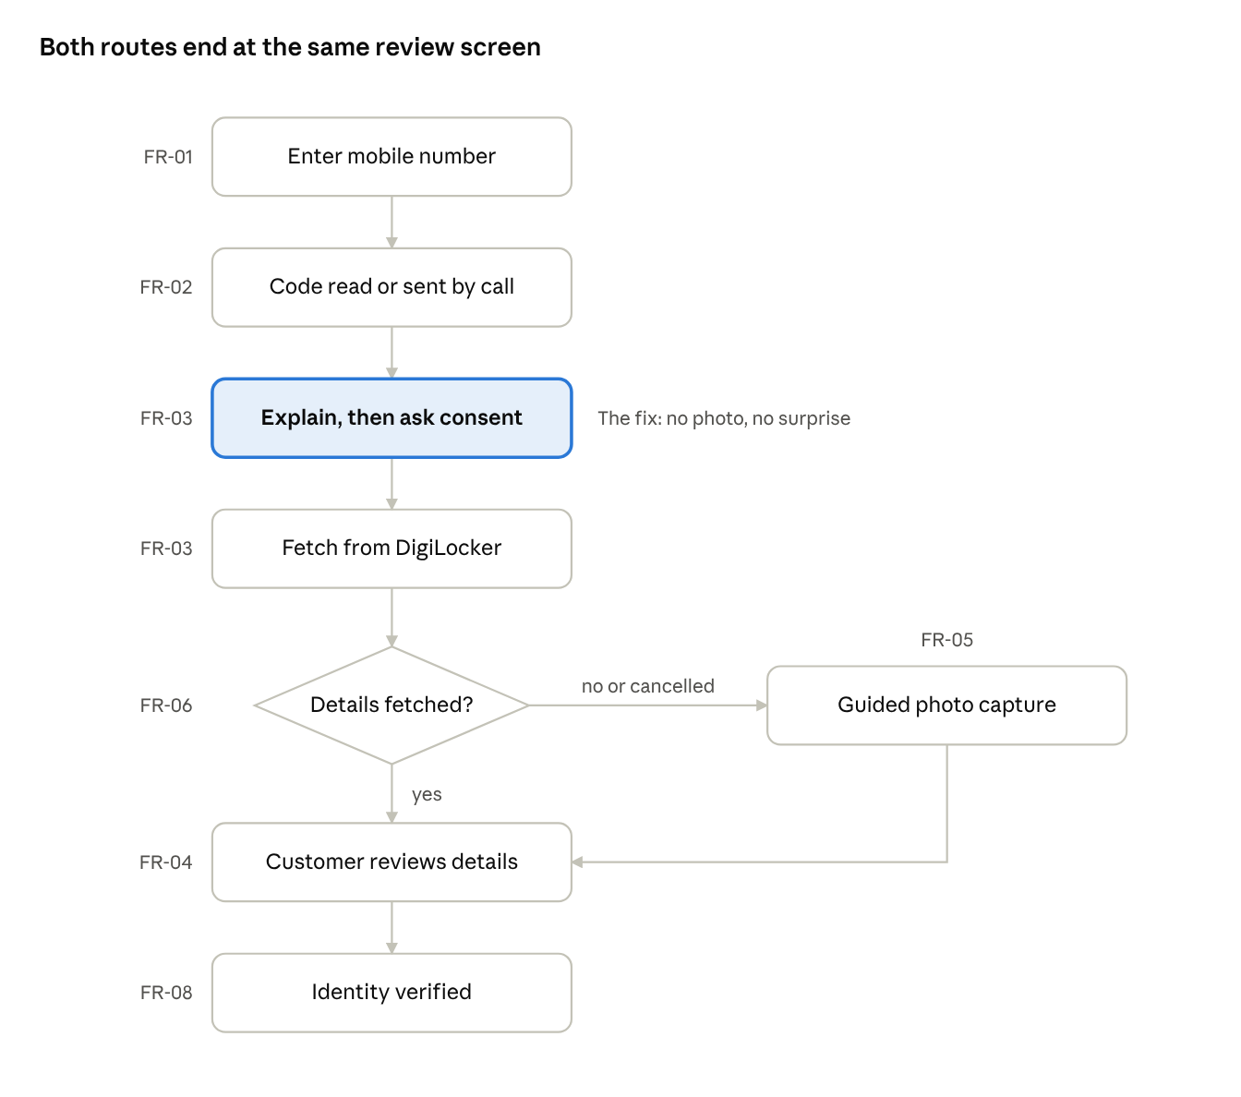
to-be onboarding flow · 6 steps, 1 decision
If DigiLocker returns the details, the customer goes straight to review. If it fails or the customer cancels, the photo route takes over and joins the same review screen (FR-04, FR-05, FR-06). Customers who find their details wrong at review also move to the photo route.

Part C: Traceability and Testing

1. Traceability matrix
Every business and regulatory requirement maps to at least one functional requirement, one prototype screen where it applies, and one test case.
Requirement | Built by | Prototype screen | Test cases
BR-01 No document photo needed | FR-03 | Consent, DigiLocker handoff | TC-05, TC-06
BR-02 Say what is taken and why | FR-03 | Consent | TC-04
BR-03 Alternate route with reasons | FR-05, FR-06, NFR-01 | Photo capture | TC-09, TC-10, TC-13
BR-04 Code by another channel | FR-02 | Code | TC-02, TC-03
BR-05 Show steps ahead | FR-01, NFR-05 | Mobile number | TC-01
BR-06 Tag every exit | FR-07 | None (analytics events) | TC-11
BR-07 Confirm details | FR-04 | Review | TC-07, TC-08
REG-01 Consent before fetch | FR-03, FR-08, NFR-03 | Consent | TC-04, TC-05
REG-02 Aadhaar number masked | FR-04 | Review | TC-07
REG-03 Keep only needed data | FR-03, NFR-02 | Consent, DigiLocker handoff | TC-06
REG-04 Audit record | FR-08, NFR-06 | None (audit view) | TC-05, TC-12

2. UAT test cases
Thirteen test cases cover all eight functional requirements and the one availability requirement.
ID | Scenario | Expected result | Covers
TC-01 | Open sign-up on a new device | First screen shows four steps and names the identity step | FR-01
TC-02 | Request a code and let the SMS arrive | Code fills in on its own and the continue button works | FR-02
TC-03 | Request a code by call after an SMS | A call is placed, the earlier SMS code stops working | FR-02
TC-04 | Open the identity step without ticking consent | Fields taken and not taken are listed, and continue is disabled | FR-03
TC-05 | Tick consent and continue | A consent record with time and text version exists before any data is requested | FR-03, FR-08
TC-06 | Complete a DigiLocker fetch | Only name, date of birth, address and photo are stored, plus the masked Aadhaar number | FR-03
TC-07 | Reach the review screen | Aadhaar number shows only its last four digits | FR-04
TC-08 | Tap "Something's wrong" on review | The photo route opens and the mismatch is logged | FR-04
TC-09 | Take a photo with glare | The screen names the cause and what to change, and earlier entries are kept | FR-05
TC-10 | Cancel at DigiLocker | A message appears with try again and use a photo, and a retry records consent again | FR-06
TC-11 | Leave at the consent screen, then at a photo rejection | The first exit is tagged trust-driven, the second technical-driven | FR-07
TC-12 | Search the audit view by customer ID | All consent and verification records for that customer return | FR-08
TC-13 | Make DigiLocker unavailable | The customer is told, and the photo route still completes | NFR-01

Part D: Process models (BPMN and UML)
Three diagrams show the Aadhaar step as it works today, as it should work, and the message order inside the DigiLocker fetch. They use BPMN notation (events, tasks, gateways, lanes) and UML sequence notation.

1. BPMN as-is: Aadhaar step today
The as-is process loops. A failed image check shows a generic error and returns the customer to the upload, and the only other exit is leaving the app.
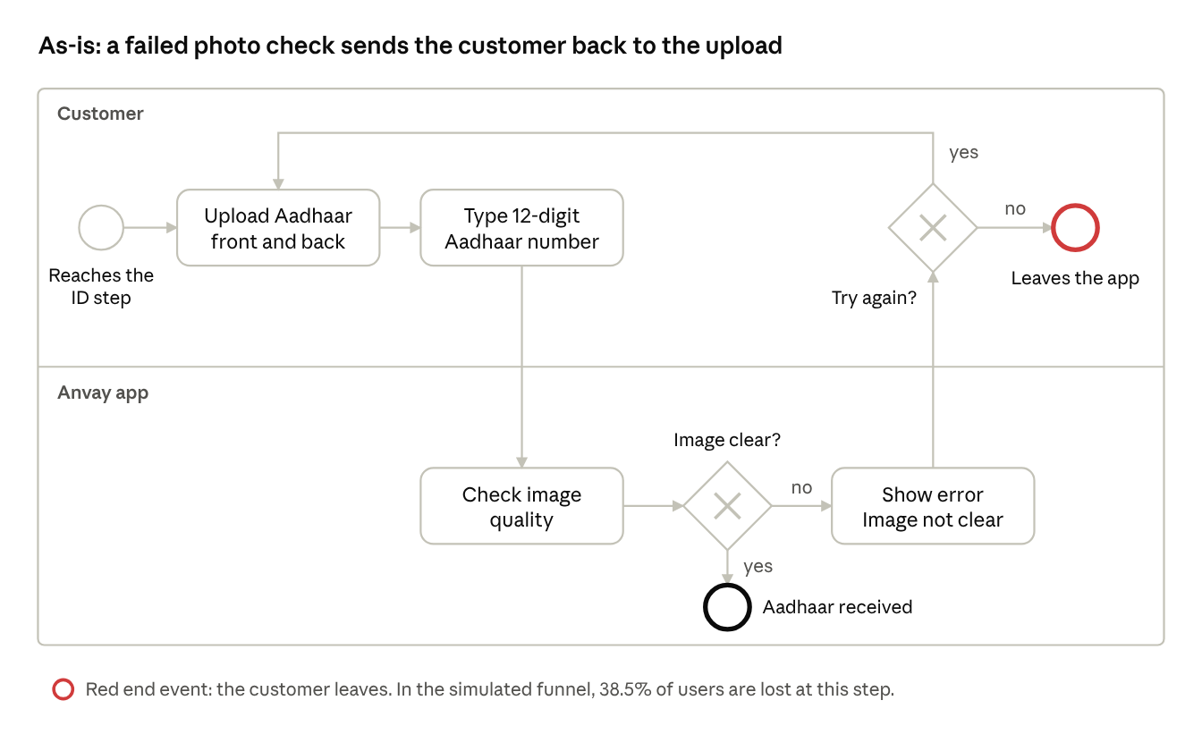
BPMN as-is, Aadhaar step · 2 lanes, 2 gateways, 2 end events
Each pass round the loop costs the customer a full re-upload, and the error never says what to fix. This is the trust-driven and technical-driven drop-off from the BRD (Section 2).

2. BPMN to-be: Aadhaar step with DigiLocker
In the to-be process, the customer consents first and DigiLocker supplies the details, so a photo is needed only when the fetch fails or is cancelled.
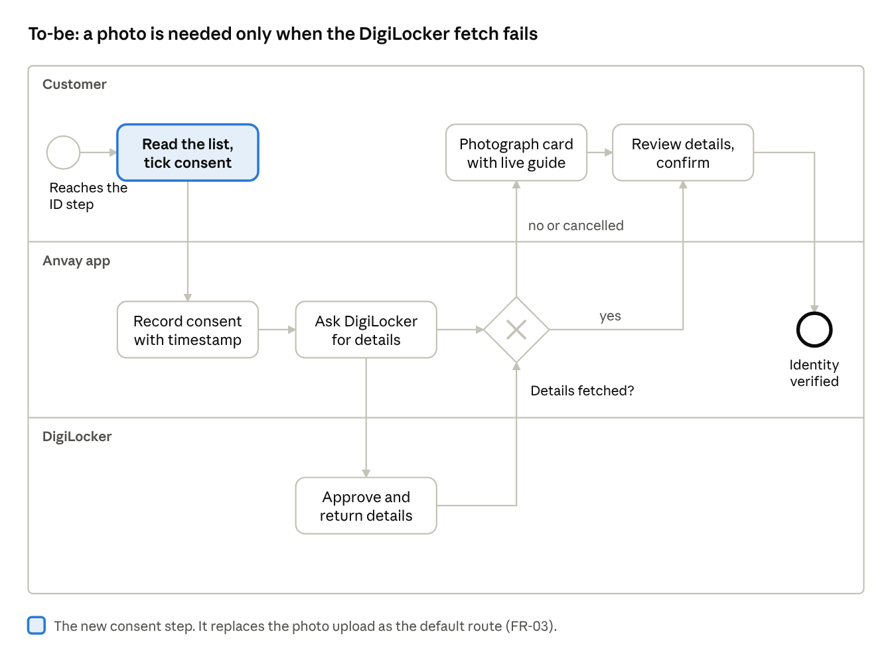
BPMN to-be, Aadhaar step · 3 lanes, 1 gateway, 1 end event
Consent is recorded before any request is sent (REG-01, FR-03). Both routes end at the same review task, and the result is logged when identity is verified (FR-04, FR-08). Customers who find their details wrong at review also move to the photo route (FR-04).

3. UML sequence: DigiLocker fetch
The consent write comes before the request to DigiLocker, and a failed fetch hands control back to the customer instead of ending the flow.
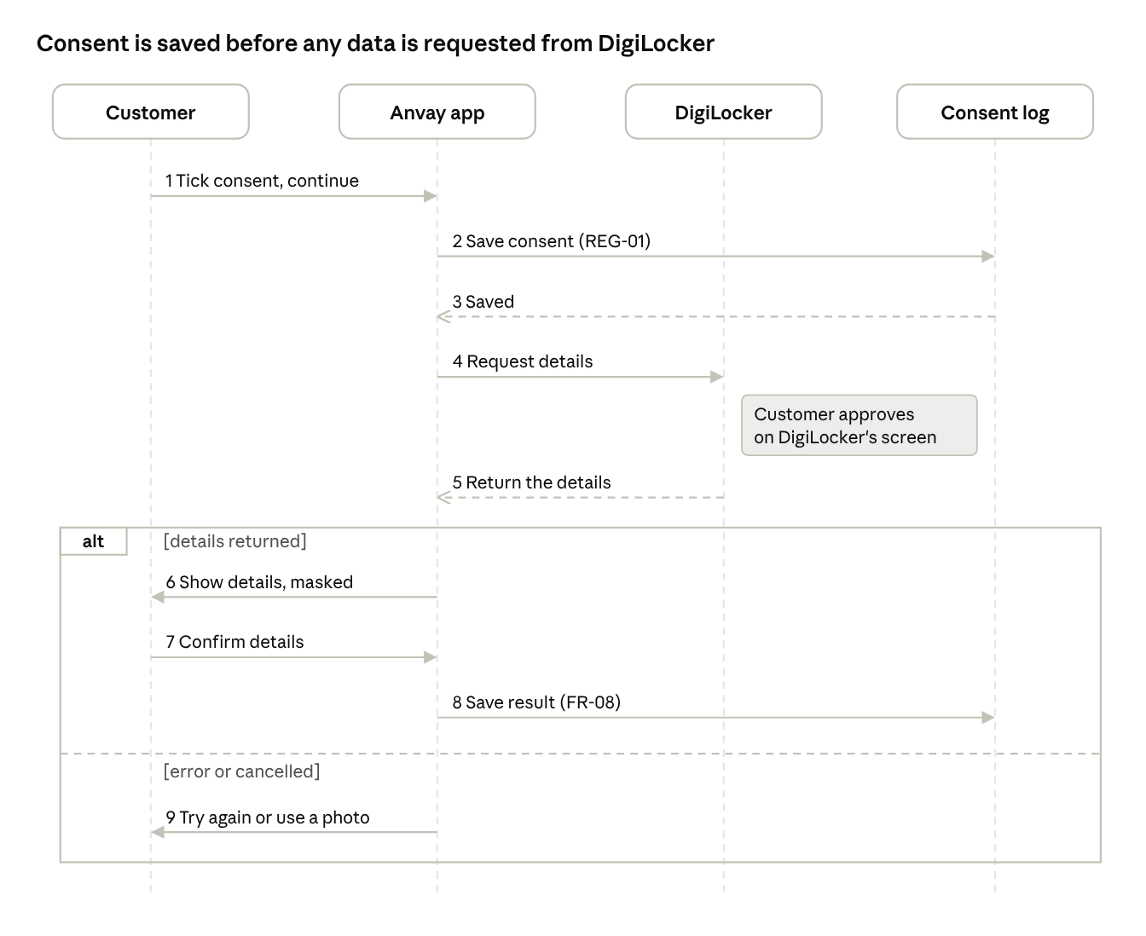
UML sequence, DigiLocker fetch · 4 lifelines, 9 messages, 1 alt
Messages | Requirement
1 to 3 | REG-01, FR-03: consent is saved before anything is requested
4 to 5 | FR-03: details are fetched from DigiLocker after the customer approves there
6 | REG-02, FR-04: the Aadhaar number is shown masked
8 | FR-08, REG-04: the result is saved for audit
9 | FR-06: a failed or cancelled fetch gives the customer a way forward

